

**Title**

|  |  |
| --- | --- |
| Complete Title | Database Installation and Configuration on Ubuntu System |
| Brief Title | Mongo Database Installation |

Approval

|  |  |
| --- | --- |
| Approver | Ankur Mishra - [ankur@toucanus.com](mailto:ankur@toucanus.com)  Hareesh Kakarla - [hkakarla@toucanus.com](mailto:hkakarla@toucanus.com) |
| Approval Date |  |
| Date to Initiate Next Version |  |

Reviewers

|  |  |  |  |  |
| --- | --- | --- | --- | --- |
| Review # | Start | End | Additional Review Required (Yes/No) | Reviewers |
| 1 |  |  |  | Venkata RamanaRao - v[enkata.ponnapalli@toucanus.com](mailto:venkata.ponnapalli@toucanus.com) |
|  |  |  |  |  |
|  |  |  |  |  |

Revision History

|  |  |  |  |
| --- | --- | --- | --- |
| Date | Author | Comments | Version |
| 11/18/2024 | venkata subrahmanyeswarao [venkata.subrahmanyeswarao@toucanus.com](mailto:venkata.subrahmanyeswarao@toucanus.com) | Draft | 1.0 |
|  |  |  |  |

### 

### 

### 

### 

Table of contents

**Objective..............................................................................................................4**

**Scope of the Document......................................................................................4**

**General Description............................................................................................4**

**Hardware Requirements.....................................................................................5**

**Installation............................................................................................................6**

**package installation missing library files....................................................8**

**Customize MongoDB Data and Logs Directories...........................................10**

**Create MongoDB user and Group....................................................................10**

**Configuration Changes ....................................................................................11**

**Manage mongod Service..................................................................................12**

**Start mongod Service.................................................................................12**

**Verfify mongod Service ..............................................................................12**

**Stop mongod Service..................................................................................12**

**Connect or Login to Mongo Shell...............................................................12**

**Uninstall mongod ..............................................................................................13**

**Conclusion ........................................................................................................13**

**Reference Document.........................................................................................13**

### 

### **Objective**

The main goal of this document is to provide a detailed guide for Install the latest version of MongoDB on Ubuntu 22.04 and configure it with a customized data directory (/mongo/data) and log directory (/mongo/logs). It outlines the hardware requirements, step-by-step installation procedures, configuration for setting up a efficient MongoDB environment.

It provides detailed steps to Install mongodb on ubuntu environment. It should be used as a reference for both Installation and configuration Best Practices.

### **Scope of this Document**

This document provides comprehensive instructions for installing and configuring MongoDB on an Ubuntu 22.04.2 LTS system. It includes the following key sections:

**Introduction:** An overview of the document's purpose and the context of the MongoDB installation.

**Hardware Requirements:** Detailed specifications for the minimum and recommended hardware configurations to ensure optimal performance of MongoDB.

**Installation Steps:** Step-by-step procedures for installing MongoDB, including setting up the repository, installing the software, and configuring data and log directories.

### **General Description**

This document serves as a comprehensive guide for installing and configuring MongoDB on an Ubuntu 22.04.2 LTS system. It outlines the necessary steps to ensure a secure and efficient MongoDB environment, including hardware requirements, installation procedures, uninstallation.

### **Hardware Requirements**

Minimum Hardware Requirements

1. **bit Architecture** :MongoDB requires a 64-bit processor (Intel x86_64 or AMD x86_64).

**RAM** : At least 8 GB of RAM.

**CPU** : A minimum of 4 cores.

**Storage** : 20 GB of disk space. It's recommended to use SSDs for better performance2.

**Operating System** : MongoDB supports various Linux distributions924.04 LTS ("Noble"),22.04 LTS ("Jammy"),20.04 LTS ("Focal") , mac-OS, and Windows.

**Note :** MongoDB only supports the 64-bit versions of these platforms

Recommended Hardware for Production

**RAM** : 32 GB or more, depending on workload.

**CPU** : 8 cores or more.

**Storage** : SSDs with high IOPS (Input/Output Operations Per Second) for faster data access.

**Network** : Gigabit Ethernet or faster for better network performance.

Additional Considerations

**Platform Support** : MongoDB 8.0 Community Edition supports the following 64-bit Ubuntu LTS (long-term support) releases on x86_64 architecture:

24.04 LTS ("Noble"),22.04 LTS ("Jammy"),20.04 LTS ("Focal")

**Working Set** : Ensure your working set (indexes and frequently accessed data) fits in RAM for optimal performance.

**Multiple CPU Cores** : MongoDB's WiredTiger storage engine efficiently uses multiple CPU cores.

**Dedicated Server** : For best performance, run one mongod process per host

### **Installation**

**Step 1 :** MongoDB only supports the 64-bit versions of these platforms. To determine Ubuntu release running on host, run the following command.

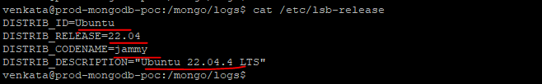

**Step 2 :** Update System - Make sure system is up to date.

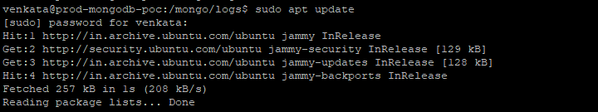

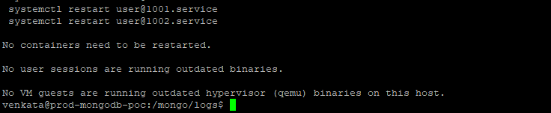

**Step 3 :** Import the MongoDB Public GPG Key MongoDB provides a GPG key for signing packages. Import it using the following command.

venkata@prod-mongodb-poc:/mongo/logs$ wget -qO - https://www.mongodb.org/static/pgp/server-6.0.asc | sudo tee /etc/apt/trusted.gpg.d/mongodb.asc

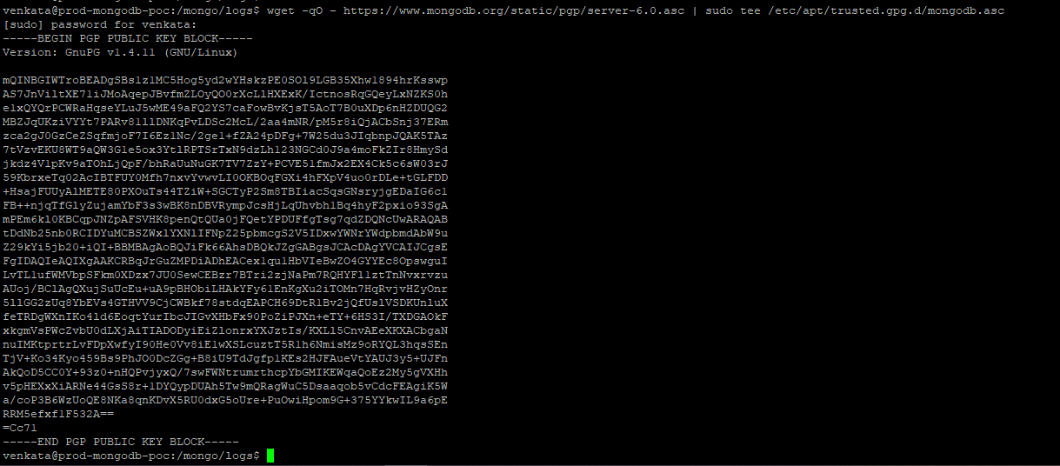

**Step 4 :** Add the official MongoDB APT Repository to sources list.

venkata@prod-mongodb-poc:/mongo/logs$ echo "deb [arch=amd64] https://repo.mongodb.org/apt/ubuntu focal/mongodb-org/6.0 multiverse" | sudo tee /etc/apt/sources.list.d/mongodb-org-6.0.list

[sudo] password for venkata:

deb [arch=amd64] https://repo.mongodb.org/apt/ubuntu focal/mongodb-org/6.0 multiverse

venkata@prod-mongodb-poc:/mongo/logs$



**Step 5 :** Update Package Database

venkata@prod-mongodb-poc:/mongo/logs$ sudo apt update

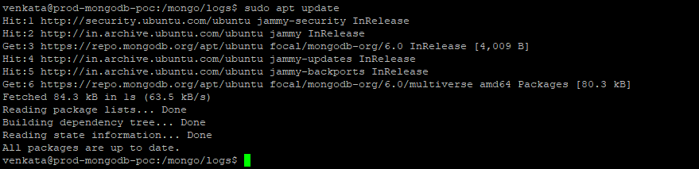

**Step 6 :**  Install MongoDB

venkata@prod-mongodb-poc:/mongo/logs$ sudo apt install -y mongodb-org

Error : The following packages have unmet dependencies:

mongodb-org-mongos : Depends: libssl1.1 (>= 1.1.1) but it is not installable

mongodb-org-server : Depends: libssl1.1 (>= 1.1.1) but it is not installable

E: Unable to correct problems, you have held broken packages.

venkata@prod-mongodb-poc:/mongo/logs$

The error you're encountering suggests that the required dependency libssl1.1 (version 1.1.1 or higher) is missing from your system, which is preventing the installation of MongoDB packages. This is likely because libssl1.1 is no longer available in the repositories for newer versions of Ubuntu or other distributions. As of Ubuntu 22.04 and later, libssl1.1 was deprecated and replaced by libssl3, which MongoDB may not be compatible with yet.

**Solution:**

6.1. Add the MongoDB repository for your system's version

venkata@prod-mongodb-poc:/mongo/logs$ wget -qO - https://www.mongodb.org/static/pgp/server-6.0.asc | sudo gpg --dearmor -o /usr/share/keyrings/mongodb-archive-keyring.gpg

venkata@prod-mongodb-poc:/mongo/logs$ echo "deb [signed-by=/usr/share/keyrings/mongodb-archive-keyring.gpg] https://repo.mongodb.org/apt/ubuntu focal/mongodb-org/6.0 multiverse" | sudo tee /etc/apt/sources.list.d/mongodb-org-6.0.list

deb [signed-by=/usr/share/keyrings/mongodb-archive-keyring.gpg] https://repo.mongodb.org/apt/ubuntu focal/mongodb-org/6.0 multiverse

venkata@prod-mongodb-poc:/mongo/logs$

venkata@prod-mongodb-poc:/mongo/logs$ sudo apt-get update

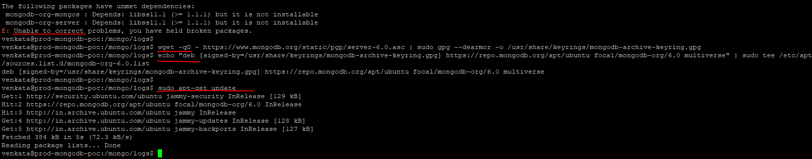

6.2. Install libssl1.1 manually (if it's not available via apt)

venkata@prod-mongodb-poc:/mongo/logs$ sudo wget http://archive.ubuntu.com/ubuntu/pool/main/o/openssl/libssl1.1_1.1.1f-1ubuntu2_amd64.deb

--2024-11-25 10:51:35-- <http://archive.ubuntu.com/ubuntu/pool/main/o/openssl/libssl1.1_1.1.1f-1ubuntu2_amd64.deb>

venkata@prod-mongodb-poc:/mongo/logs$ sudo dpkg -i libssl1.1_1.1.1f-1ubuntu2_amd64.deb

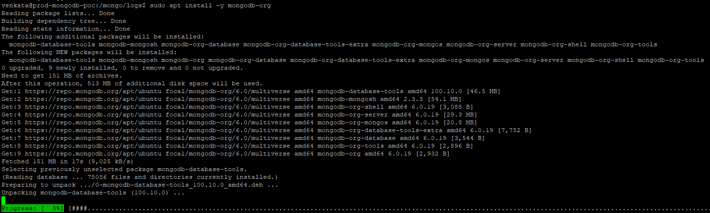

**Step 7 :** Customize MongoDB Data and Log Directories

7.1 Create the directories for data and logs if not exists

venkata@prod-mongodb-poc:/mongo/logs$ sudo mkdir -p /mongo/data

venkata@prod-mongodb-poc:/mongo/logs$ sudo mkdir -p /mongo/logs

7.2 Change the ownership of the directories to the MongoDB user (mongodb):

venkata@prod-mongodb-poc:/mongo/logs$ sudo chown -R mongodb:mongodb /mongo/data

venkata@prod-mongodb-poc:/mongo/logs$ sudo chown -R mongodb:mongodb /mongo/logs

7.3. Check user mongodb exists or not

venkata@prod-mongodb-poc:/mongo/logs$ getent passwd mongodb

venkata@prod-mongodb-poc:/mongo/logs$

If the user doesn't exist, you will see no output.

7.4 To add user and group

venkata@prod-mongodb-poc:/mongo/logs$ sudo groupadd mongodb

venkata@prod-mongodb-poc:/mongo/logs$ sudo useradd -r -g mongodb -s /bin/false -d /mongo mongodb

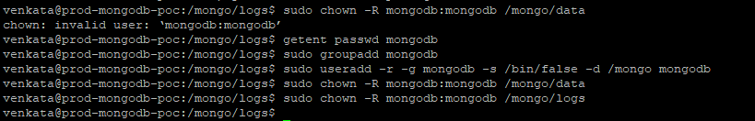

### **Configuration Changes**

Configure MongoDB to Use Custom Directories and update any configuration changes like port bindip or replication etc… edit config file and update the parameter which we want to and save

venkata@tou-dev-mongo1:~# sudo vi /etc/mongod.conf

# Where and how to store data.

storage:

dbPath: /mongo/data

# Where to write log.

systemLog:

destination: file

logAppend: true

path: /mongo/logs/mongod.log

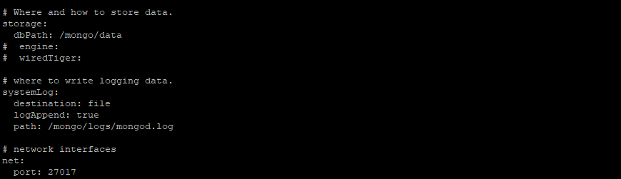

Note : Default mongodb config file is located as /etc/mongod.conf

### **Manage mongod Process**

To run and manage your [mongod](https://www.mongodb.com/docs/manual/reference/program/mongod/" \l "mongodb-binary-bin.mongod) process, you will be using your operating system's built-in [init system](https://www.mongodb.com/docs/manual/reference/glossary/" \l "std-term-init-system). Recent versions of Linux tend to use systemd (which uses the systemctl command), while older versions of Linux tend to use System V init (which uses the service command).

If you are unsure which init system your platform uses, run the following command:

venkata@tou-dev-mongo1:~# sudo systemctl enable mongod

### **Start mongod Service**

venkata@tou-dev-mongo1:~# sudo systemctl start mongod

### **Verify mongod Service**

venkata@tou-dev-mongo1:~# sudo systemctl status mongod

### **Stop mongod Service**

venkata@tou-dev-mongo1:~# sudo systemctl stop mongod

### **Connect to mongo Shell**

venkata@tou-dev-mongo1:~# mongosh

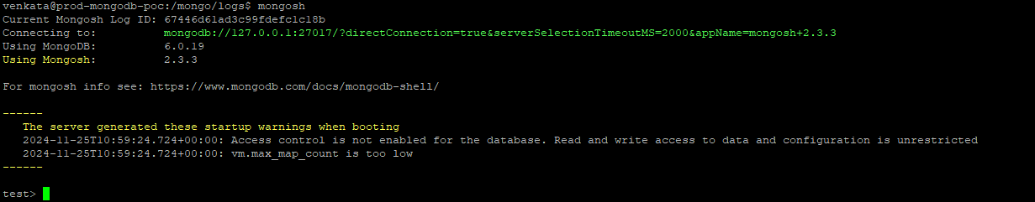

**Uninstall MongoDB Community Edition**

**Step 1 :** Stop the mongod process

venkata@tou-dev-mongo1:~# sudo systemctl stop mongod

**Step 2 :**  Disable MongoDB from Starting at Boot.

venkata@tou-dev-mongo1:~# sudo systemctl disable mongod

**Step 3 :** Uninstall mongodb package

venkata@tou-dev-mongo1:~# sudo apt purge mongodb-org*

**Step 4 : Remove mongodb data and logs**

venkata@tou-dev-mongo1:~# sudo rm -rf /mongo/data

venkata@tou-dev-mongo1:~# sudo rm -rf /mongo/logs

**Step 4 : Remove mongodb repository**

venkata@tou-dev-mongo1:~# sudo rm /etc/apt/sources.list.d/mongodb-org-6.0.list

**Step 4 : Verify removal package**

venkata@tou-dev-mongo1:~# ps aux | grep mongod

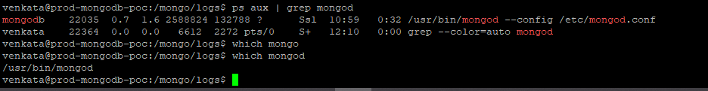

### **Conclusion**

By following these steps, You have successfully installed MongoDB APT package manager installation on Ubuntu 22.04 with customized data and log directories. MongoDB is now configured to store its data in /mongo/data and its logs in /mongo/logs, and also uninstall this mongo package.

### **References**

* <https://www.mongodb.com/docs/manual/tutorial/install-mongodb-on-ubuntu/>
* <https://www.mongodb.com/community/forums/t/installing-mongodb-over-ubuntu-22-04/159931>
* <https://github.com/subrahmanyeswaraokrv/mongodb-handbook/commit/39814ef224d04126453993fadb2a5986b5369e8e>